


QualityEducation QualityCareer QualityFuture


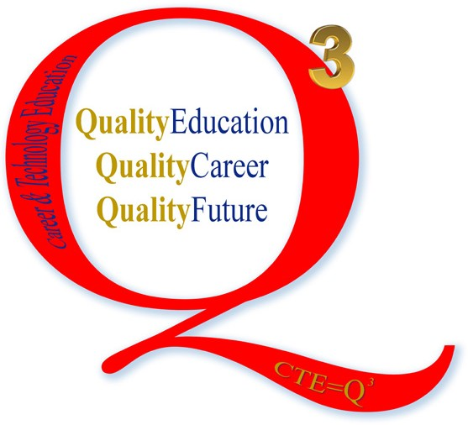


Gayle Stinson, Ed.D.

Superintendent

Elizabeth Clark, Ed.D. Associate Superintendent for Curriculum and Instruction

Andrea Anderson

Career and Technology Director

Jennifer Gotuaco, Ph.D.

Career and Technology Coordinator

Jacob Hildebrand

Career and Technology Coordinator

Joe Rocker
Career and Technology Coordinator

Career and Technology Education Department
7020 Mid Cities Blvd * North Richland Hills, TX 76180 * 817-547-3800
http://www.birdvilleschools.net/cte * http://schools.birdvilleschools.net/cte

BIRDVILLE INDEPENDENT SCHOOL DISTRICT
ASSURANCE OF NONDISCRIMINATION
Birdville Independent School District offers support to school district for career and technical education programs in Agricultural Food and Natural Resources / Architec- ture and Construction / Transportation, Distribution and Logistics / Arts, Audio Visual Technology and Communications / Hospitality and Tourism / Business Management and Administration / Finance / Marketing / Information Technology / Education and Training / Human Services / Law, Public Safety, Corrections and Security / Govern- ment and Public Administration / Health Science / Science, Technology, Engineering and Mathematics. Admission to these programs is based on enrollment in BISD secondary schools.
It is the policy of BISD not to discriminate on the basis of race, color, national origin, sex or handicap in its CTE programs, services or activities as required by Title VI of the Civil Rights Act of 1964, as amended; Title IX of the Education Amendments of 1972; and Section 504 of the Rehabilitation Act of 1973, as amended.
It is the policy of BISD not to discriminate on the basis of race, color, national origin, sex, handicap, or age in its employment practices as required by Title VI of the Civil Rights Act of 1964, as amended; Title IX of the Education Amendments of 1972; the Age Discrimination Act of 1975, as amended; and Section 504 of the Rehabilitation Act of 1973, as amended.
BISD will take steps to assure that lack of English language skills will not be a barrier to admission and participation in all educational and CTE programs.
For information about your rights or grievance procedures, contact the Title IX Coordinator, Skip Baskerville at 6125 Belknap Street, Haltom City, Texas 76117 or 817- 547-5700.
District scolaire indépendant de Birdville ofrece apoyo al distrito escolar para programas de educación técnica y profesional en Alimentos Agrícolas y Recursos Naturales
/ Arquitectura y Construcción / Transporte, Distribución y Logística / Artes, Audio Visual Tecnología y Comunicaciones / Hostelería y Turismo / Gestión y Administración de Empresas / Finanzas / Marketing / Tecnologías de la Información / Educación y Formación / Servicios Humanos / Derecho, Seguridad Pública, Correcciones y Seguri- dad / Gobierno y Público Administración / Ciencias de la Salud / Ciencias, Tecnología, Ingeniería y Matemáticas. La admisión a estos programas se basa en la inscripción en escuelas secundarias BISD.
Es norma de BISD no discriminar por motivos de raza, color, origen nacional, sexo o impedimento, en sus programas, servicios o actividades de CTE, tal como lo requieren el Título VI de la Ley de Derechos Civiles de 1964, según enmienda; el Título IX de las Enmiendas en la Educación, de 1972, y la Sección 504 de la Ley de Rehabilitación de 1973, según enmienda.
Es norma de BISD no discriminar por motivos de raza, color, origen nacional, sexo, impedimento o edad, en sus procedimientos de empleo, tal como lo requieren el Título VI de la Ley de Derechos Civiles de 1964, según enmienda; el Título IX de las Enmiendas en la Educación, de 1972, la ley de Discriminación por Edad, de 1975, según enmienda, y la Sección 504 de la Ley de Rehabilitación de 1973, según enmienda.
BISD tomará las medidas necesarias para asegurar que la falta de habilidad en el uso del inglés no sea un obstáculo para la admisión y participación en todos los pro- gramas educativos y CTE.
Para información sobre sus derechos o procedimientos para quejas, comuníquese con el Coordinador del Título IX, Skip Baskerville en 6125 Belknap Street, Haltom City, Texas 76117 or 817-547-5700.


“Career and Technology Education embraces quality instructional partnerships with business and industry to successfully prepare students to position themselves for the
challenges of post-secondary education and to excel with integrity in a globally competitive workplace.”

Introduction
Birdville Independent School District’s Career and Technology Education program is nationally recognized. We credit this success to strong support by BISD’s Board of Trustees and Superintendent in providing resources necessary for quality programs for BISD students.

We embrace an attitude of continuous improvement by keeping abreast of current trends in business and industry. It is through the involvement and teamwork among members of the BISD family, parents, and our business and post-secondary partners that we are able to provide relevant “real world” experiences coupled with high academic standards that greatly enhance our students’ future successes. “Career and Technology Education embraces quality instructional partnerships with business and industry to successfully prepare students to position themselves for the challenges of post-secondary education and to excel with integrity in a globally competitive workplace.”

We invite you to look at our high school graduation program offered to students with endorsement areas of study that follow each student’s career pathway of choice that combines academic success and technical skill acquisition. We are also excited about the partnerships with business and industry that give students a chance to spend time in practicum programs as paid or unpaid interns. BISD Career and Technology Education is a great way for students to prepare for the highly technological and competitive workplace of the 21st Century.

Upon request, specific sections of this publication can be made available in multiple languages by contacting Michelle DoPorto in the Birdville ISD Communications office via email at michelle.doporto@ems-isd.net.



BIRDVILLE INDEPENDENT SCHOOL DISTRICT

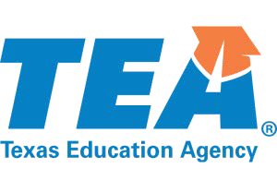
CTE Programs of Study

The Division of College, Career and Military Preparation has engaged members of the workforce, secondary education, and higher education to advise on the development of programs of study, including coherent se- quences of courses, industry-based certifications, and work-based learning to ensure students are prepared for in-demand, high-skill, high-wage careers in Texas.

















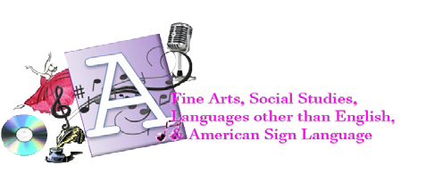

Begin Planning Here!
Multi-disciplinary Studies
Arts & Humanities
STEM (Science, Technology, Engineering & Mathematics)
Business & Industry
Public Services

Endorsements
To earn an endorsement a student must successfully complete:
- Courses related to endorsement
Technology (.5 credit)
Endorsement Coursework / Electives (5.5 credits)
26 Credits Total
Professional Communications (Speech) (.5 credit)
Health (.5 credit)
Fine Arts (1 credit)
Physical Ed. (1 credit)
Social Studies (3 credits)
US History, US Gov’t/Economics, and World Geography or World History
World Languages(2 credits)
Science (4 credits)
Biology (IPC, Chemistry, or Physics) and 2 Advanced Science courses
Math (4 credits)
Algebra I, Geometry, Algebra II , and an Advanced Math course required for endorsement
English (4 credits)
English I, II, and III, and an Advanced English course
STEM:
(Science, Technology, Engineering & Mathematics)
- Science
- Technology
- Engineering
- Mathematics
BUSINESS & INDUSTRY:
- Agriculture, Food and Natural Resources
- Architecture and Construction
- Arts, A/V Technology and Communications
- Business, Management and Administration
- Finance
- Hospitality and Tourism (Culinary Arts)
- Information Technology
- Manufacturing
- Marketing, Sales and Service
- Transportation and Logistics (Auto Technology)
- Advanced Broadcast Journalism, Newspaper or Public Speaking
PUBLIC SERVICES:
- Education and Training
- Health Science
- Law, Public Safety, Corrections and Security
- Government and Public Administration
- Human Services
- JROTC
ARTS & HUMANITIES:
- Art
- Dance
- Music
- Theater
- Social Studies
- American Sign Language
- World Languages
MULTIDISCIPLINARY STUDIES:
Allows a student to complete prescribed courses from each of the four foundation subject areas, advanced placement courses from each of the four foundation subject areas or four advanced courses from within one endorsement area or among endorsement areas not in a coherent sequence.


Birdville ISD Graduation Plan

It is the responsibility of each college-bound student to research admission requirements, as each college’s requirements may differ.
Performance Acknowledgement
A student may earn a performance acknowledgement on their diploma for outstanding performance on any of the following:
- Completing at least 12 hours of college academic courses including those taken for dual credit and advanced technical credit.
- Bilingual and Biliteral
- On a college AP or IB exam
- On the PSAT, ACT-PLAN, SAT or ACT
- For earning a nationally or internationally recognized industry certification
Distinguished Level of Achievement (26 credits)
To earn a distinguished level of achievement a student must successfully complete the curriculum requirements for at least one endorsement, including 4 credits in science and 4 credits in mathematics to include Algebra II.

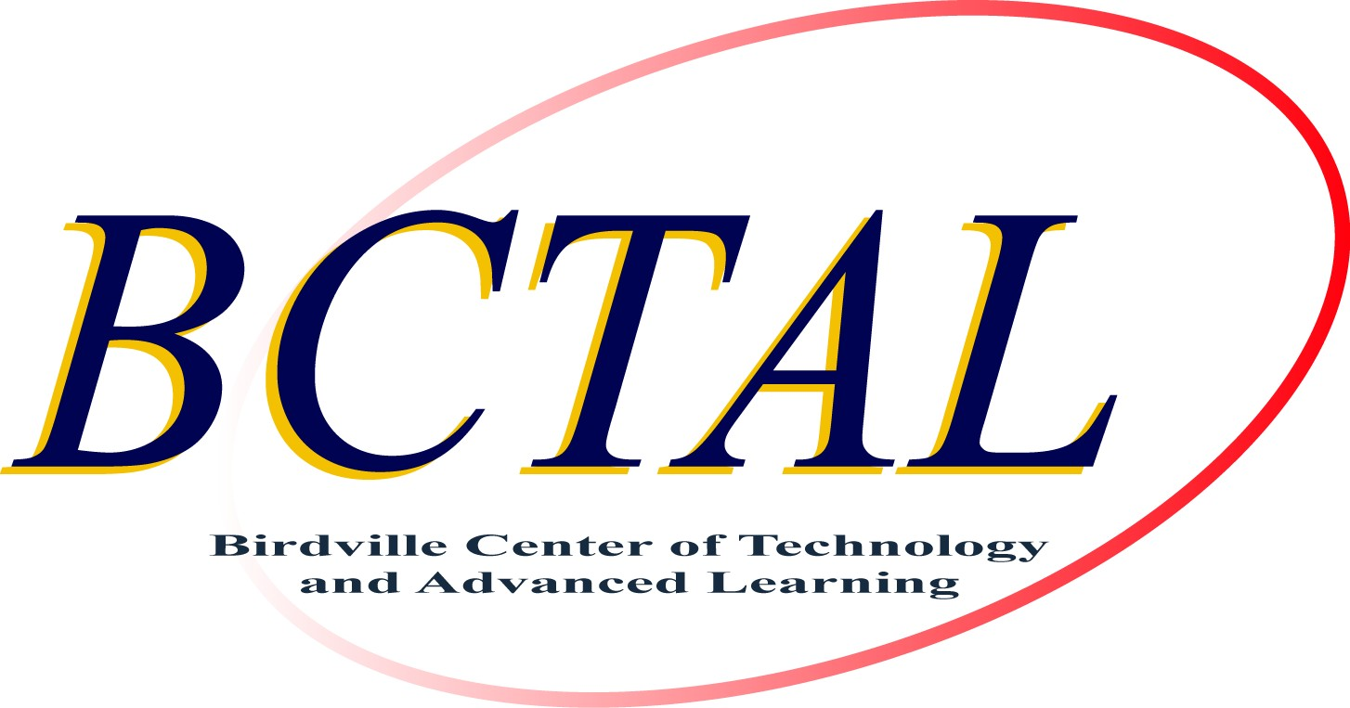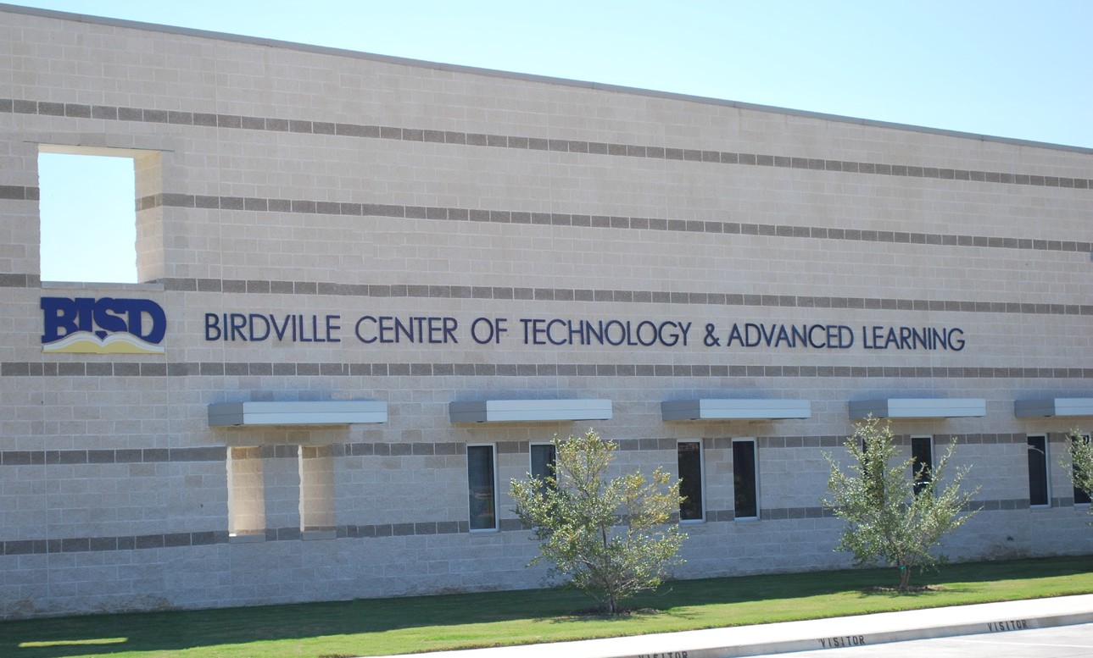

Classes offered at BCTAL

911 Emergency Telecommunications | Digital Electronics | Law Enforcement
Accounting (Dual Credit) | Drone Aerospace Systems | Livestock Production
Advanced Animal Science | EKG/Phlebotomy Technician | Medical Administrative Assistant
Advanced Plant and Soil Science | Emergency Medical Technician | Medical Microbiology
Agriculture Mechanics and Metal Technologies | Equine Science | Medical Terminology
Audio Video Production | Firefighter | Pathophysiology
Automotive Technology | Floral Design | Pharmacology
CISCO Systems | Forensic Science | Practicum in Business Management
Clinical Rotation | Global/Virtual Business | Prin. Agriculture, Food and Natural Res.
Computer Maintenance | Health Science | Engineering Science
Construction Technology | PAP Anatomy & Physiology | Principles of Technology
Cosmetology | Horticulture Science | Robotics
Court Systems & Practice | Horticulture Science | Rocket Engineering
Criminal Investigations | Hotel Management | Travel & Tourism
Culinary Arts

College and Career Readiness

Career and Technology Education fosters a culture of college and career readiness. Programs of Study
(or Personal Graduation Plans), career pathways, and dual credit, help students understand how education and training connect to the world of work.

CTE has active student organizations involved in state and national competitions. Students have the opportunity to earn industry-recognized certifications and licensures, leading to either more specialized instruction in a given field, or a leap forward on the path of postsecondary education.


Outstanding Business Partner
Tito Rodriguez
City of North Richland Hills, Council Member
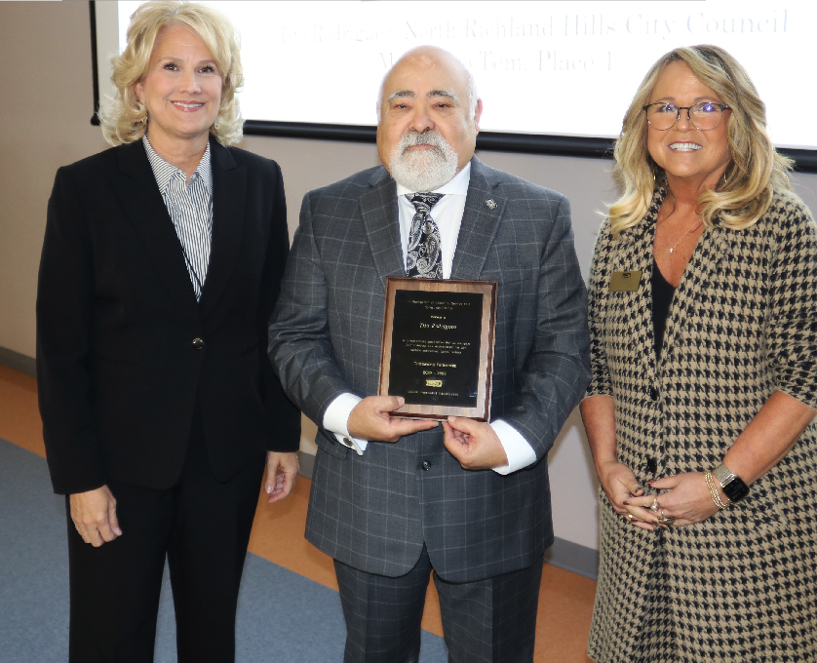
Dr. Gayle Stinson, BISD Superintendent (left),
Tito Rodriguez, City of North Richland Hills, Council Member (center)
and Allison Vinson, Director of CTE (right)


BISD has a wide variety of Business and Marketing courses that allow students to receive
certification as Microsoft Office User Specialists. Birdville students also have the opportunity to train in
local businesses through internships in Business Education and Marketing Education.

Internships are designed to give students supervised practical application in the world of work. These experiences occur in paid or unpaid arrangements and at a variety of locations appropriate
to the nature and level of experience. Students implement personal and interpersonal skills to strengthen individual performance in the workplace and in society. These same skills enable the students to make a successful transition to the workforce or postsecondary education.

BISD partners with Unity One Credit Union. Unity One assists students with financial literacy and par- ticipates with student internships while offering financial services to the community at this new branch location. Dual Credit Accounting is another way students are able to learn accounting
principles in high school while earning college credit. Students enjoy the experience and knowledge of a TCC instructor, then work with a BCTAL teacher who enhances the concepts presented. Due
to the level of rigor in the course, BISD has implemented this rotation to offer support and encouragement to these accounting students.

Journalism Credits Grade
HS | Journalism (Principles Arts A/V & Communications)* | 1 | 9-12
HS | Yearbook 1 (Graphic Design & Illustration)* | 1 | 10-12
HS | Yearbook 2 (Advanced Graphic Design & Illustration)* | 1 | 11-12
HS | Yearbook 3 (Practicum Graphic Design & Illustration) | 2 | 12
HS | Newspaper 1 (Printing & Imaging Technology)* | 1 | 10-12
HS | Newspaper 2 (Printing & Imaging Technology 2)* | 1 | 11-12
HS | Newspaper 3 (Practicum Printing & Imaging Technology) | 2 | 12
HS | Commercial Photography* | 1 | 9-12
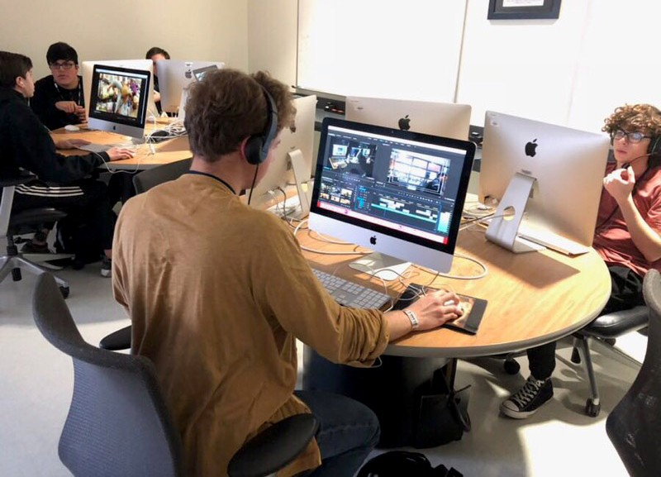
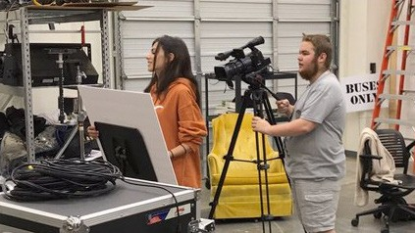
Agricultural Food and Natural Resources Credits Grade

BCTAL | Principles of Agriculture, Food and Natural Resources | 1 | 9-12
BCTAL | Wildlife, Fisheries and Ecology Management | 1 | 9-12
BCTAL | Livestock Production | 1 | 10-12
BCTAL | Equine Science | 1/2 | 10-12
BCTAL | Small Animal Management | 1/2 | 10-12
BCTAL | Advanced Animal Science (Science Credit) | 1 | 11-12
BCTAL | Floral Design (Fine Arts Credit) | 1 | 10-12
BCTAL | Advanced Floral Design | 1 | 11-12
BCTAL | Greenhouse Operation and Production | 1 | 10-12
BCTAL | Horticulture Science | 1 | 10-12
BCTAL | Advanced Plant and Soil Science (Science Credit) | 1 | 11-12
BCTAL | Veterinarian Medical Applications | 1 | 11-12
BCTAL | Practicum Agriculture Food and Natural Resources | 2 | 11-12
BCTAL | Mathematical Apps. in Ag. Food and Nat. Resources | 1 | 10-12
BCTAL | Agricultural Mechanics and Metal Technologies | 2 | 11-12

The food, horticulture and fiber industry is the second-largest industry in Texas, generating over $73 billion a year. The Birdville Agricultural Science Center in Haltom City currently houses livestock that students raise and show. Horticulture is located centrally at BCTAL and offers students an opportunity to work with a wide variety of annual and perennial plants, as well as practice horticultural and landscape design.
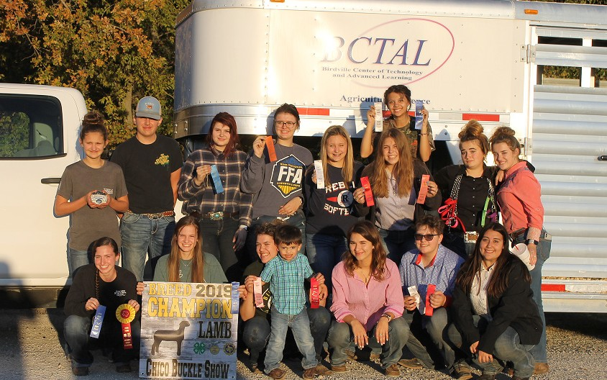

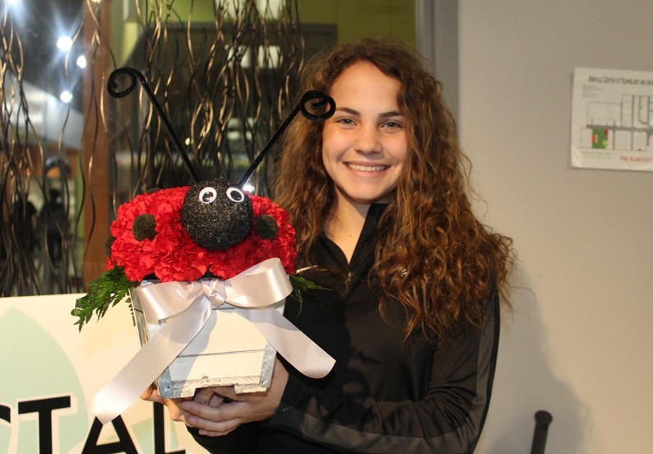

Architecture and Construction | Credits | Grade
HS Civil Engineering & Architecture | 1 | 10-12
BCTAL Construction Technology | 2 | 9-12
BCTAL Construction Technology 2 | 2 | 10-12
BCTAL Practicum in Construction Technology 3 | 2 | 11-12
BCTAL Practicum in Construction Technology 4 | 2 | 12
HS Interior Design | 1 | 10-11
HS Advanced Interior Design | 1 | 10-12

* Meets technology requirement. Location: BCTAL-Birdville Center of Technology and Advanced Learning, HS-high school campus. Unless otherwise stated, courses are offered at all high school campuses based on student enrollment.
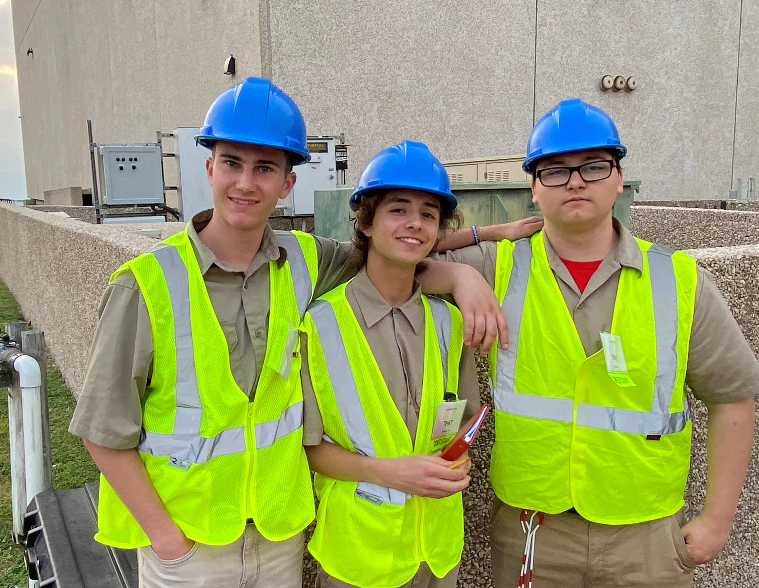
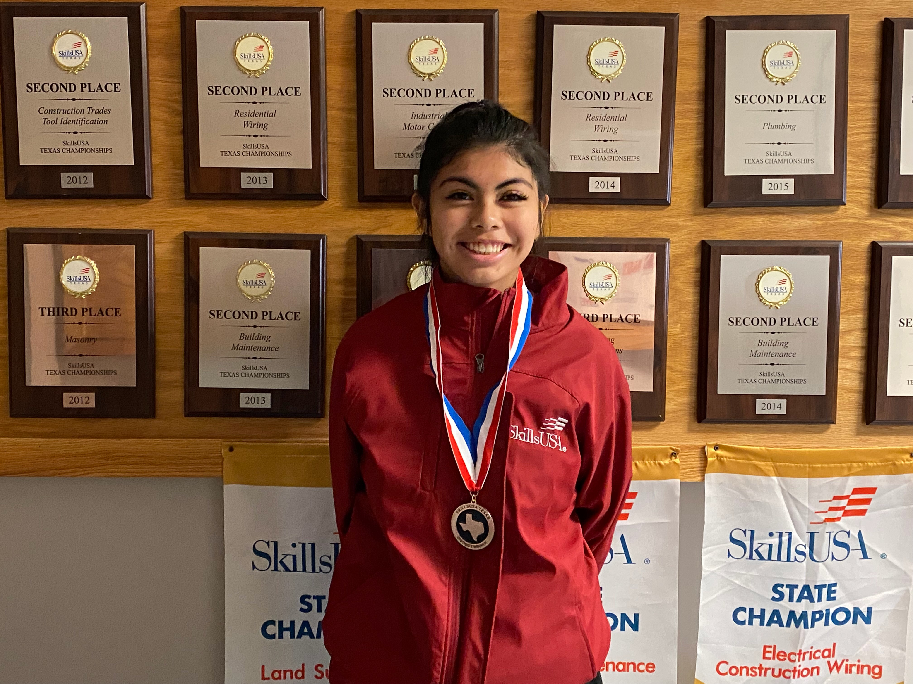

Transportation, Distribution and Logistics | Credits | Grade
BCTAL Energy, Power and Transportation Systems | 1 | 9-12
BCTAL Principles of Transportation Systems | 1 | 9-12
BCTAL Automotive Technology | 2 | 10-12
BCTAL Automotive Technology 2 | 3 | 10-12
BCTAL Advanced Automotive Technology 3 | 3 | 12
TCC Aircraft Technology (Dual Credit) | 3 | 11-12
TCC Advanced Aircraft Technology (Dual Credit) | 3 | 11-12

Location: BCTAL-Birdville Center of Technology and Advanced Learning, TCC-Tarrant County College, HS - high school campus. Unless otherwise stated, courses are offered at all high school campuses based on student enrollment.
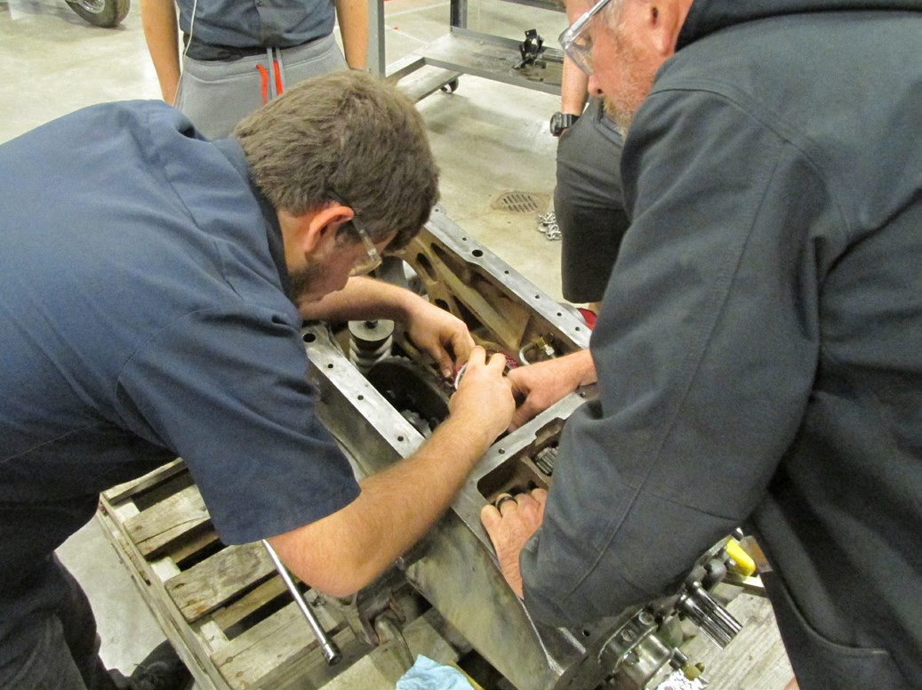
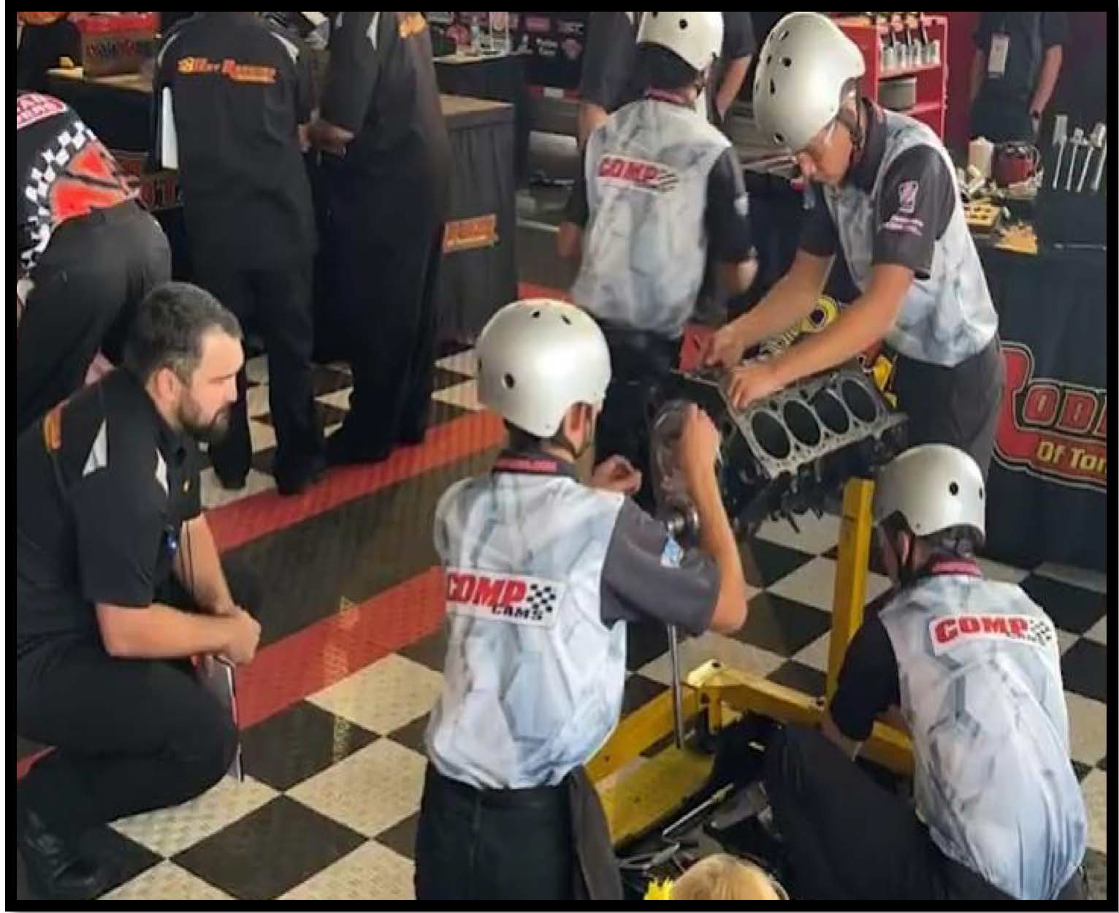

Birdville ISD has a state of the art Audio Video Technology program with a full production studio at the Birdville Center of Technology and Advanced Learning. The program allows students to work with industry-standard equipment and broadcast to the community on cable Channel 30. In an effort to stay in step with the industry, BISD is the ONLY high school in Texas to be shooting on 16mm film.
Arts, Audio Video Technology and Communications Credits Grade

HS | Graphic Design and Illustration* | 1 | 9-12
HS | Graphic Design and Illustration 2* | 1 | 10-12
HS | Animation* | 1 | 10-12
HS | Animation 2* | 1 | 11-12
HS | Fashion Design | 1 | 10-12
HS | Fashion Design 2 | 1 | 10-12
BCTAL | Audio Video Production 1* | 2 | 10-12
BCTAL | Advanced Video Production 2* (Dual Credit) | 2 | 11-12
BCTAL | Practicum Video Production 3* | 2 | 12
BCTAL | Advanced Audio Production 2* | 2 | 10-12
BCTAL | Practicum Audio Production 3* | 2 | 11-12
HS | Professional Communications (Speech Credit) | 1/2 | 9-12


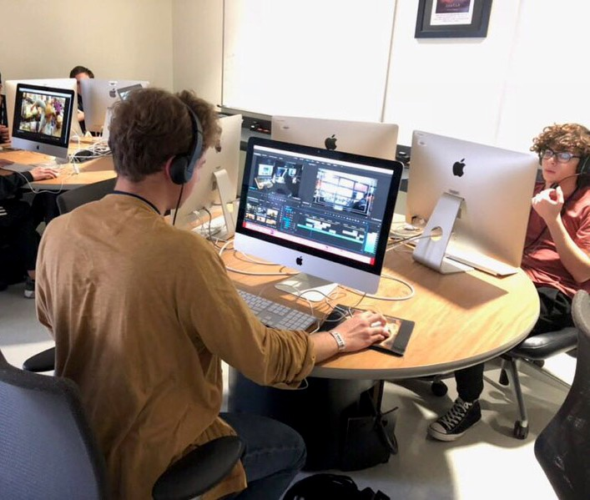
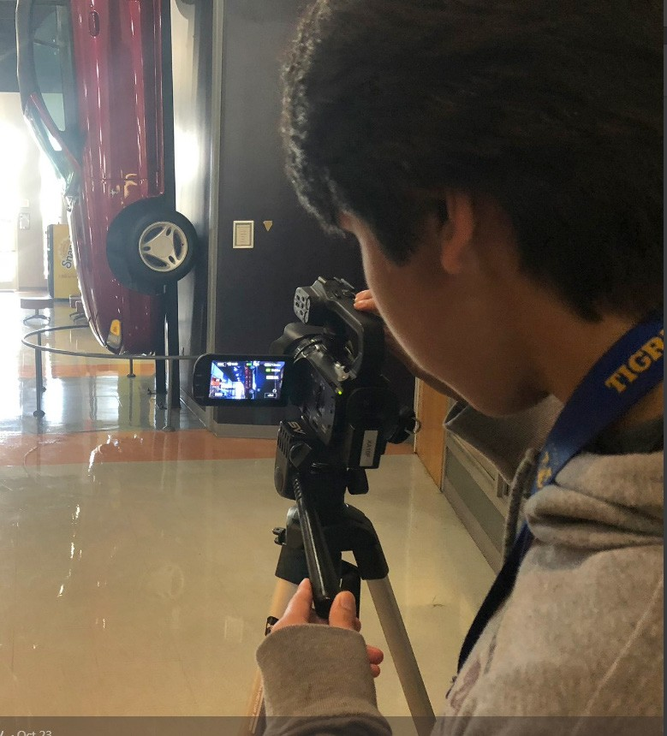
*Meets technology requirement. Location: BCTAL-Birdville Center of Technology and Advanced Learning, HS-high school campus. Unless otherwise stated, courses are offered at all high school campuses based on student enrollment.

BISD’s Audio Video Production program is designed to help students get a jump start on a career in the audio video industry. We are an Adobe authorized testing center as well as offering training in many other industry softwares. Our curriculum includes hands on education in such fields as audio engineering, filmmaking, sound design, recording, editing, television production and much more.


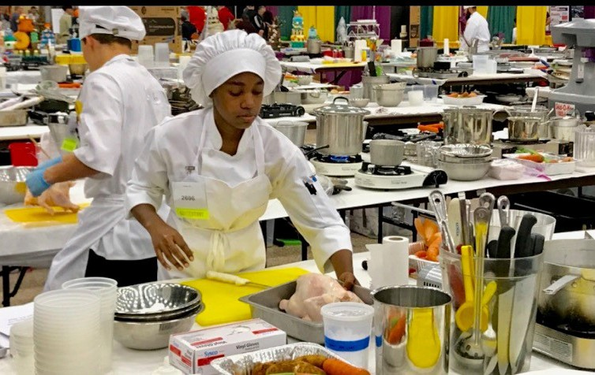
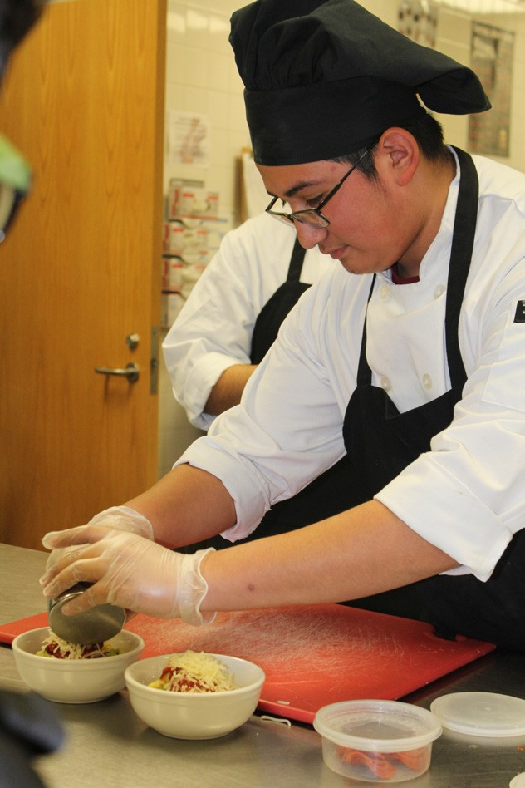
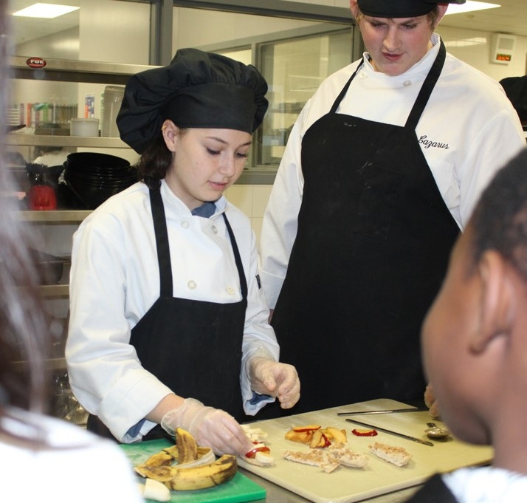
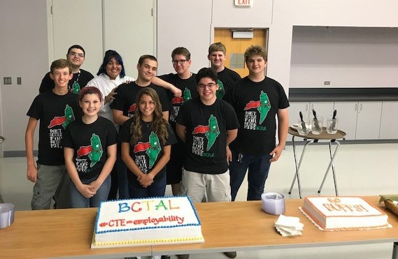
Culinary Arts begins with the fundamental principles of the art of cooking and the science of baking and includes management and production skills and techniques. Culinary Arts courses may be offered as a laboratory-based class centered around the BISTRO at the Birdville Center of Technology and Advanced Learning.
Hospitality and Tourism encompasses lodging; travel and tourism, recreation, amusements, attractions and resorts; and restaurants and food and beverage service. The hospitality and tourism industry maintains the largest national employment base in the private sector. Students use knowledge and skills that meet industry standards to function effectively in various positions within this multifaceted industry.

Hospitality and Tourism Credits |  |  |  | Grade
BCTAL | Culinary Arts | 1 | 2 | 10-12
BCTAL | Culinary Arts 2 |  | 2 | 11-12
BCTAL | Culinary Arts 3 |  | 2 | 11-12
BCTAL | WBL Culinary Arts (Extended Practicum) |  | 3 | 11-12
BCTAL | Hotel Management |  | 1 | 10-12
BCTAL | Restaurant/Culinary |  | 1 | 10-12
BCTAL | Travel & Tourism Mgmt./Prin. of Hosp. & Tourism |  | 2 | 10-12
BCTAL | Practicum in Hospitality Services |  | 2 | 12
HS | Food Science (Science Credit) |  | 1 | 11-12


Business Management and Administration Credits Grade

HS | Principles of Business, Marketing and Finance | 1 | 9-10
BCTAL | Practicum in Business Management 1* | 3 | 11-12
BCTAL | Practicum in Business Management 2* | 3 | 12
BCTAL | Global Business | 1/2 | 10-12
BCTAL | Virtual Business | 1/2 | 10-12
BCTAL | Business Law | 1 | 11-12
BCTAL | Business English | 1 | 12
HS | Business Information Management 1* | 1 | 9-10
HS | Business Information Management 2* | 1 | 10-12

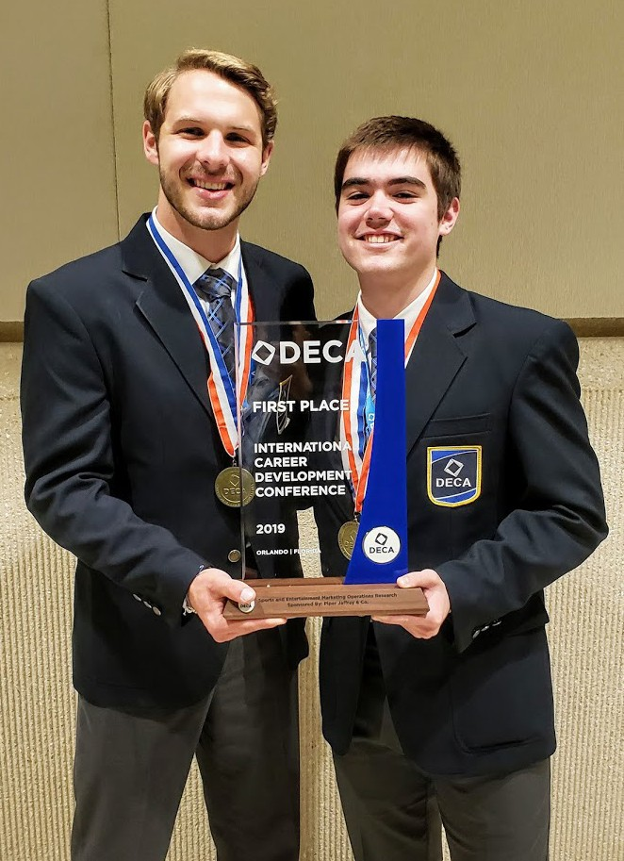
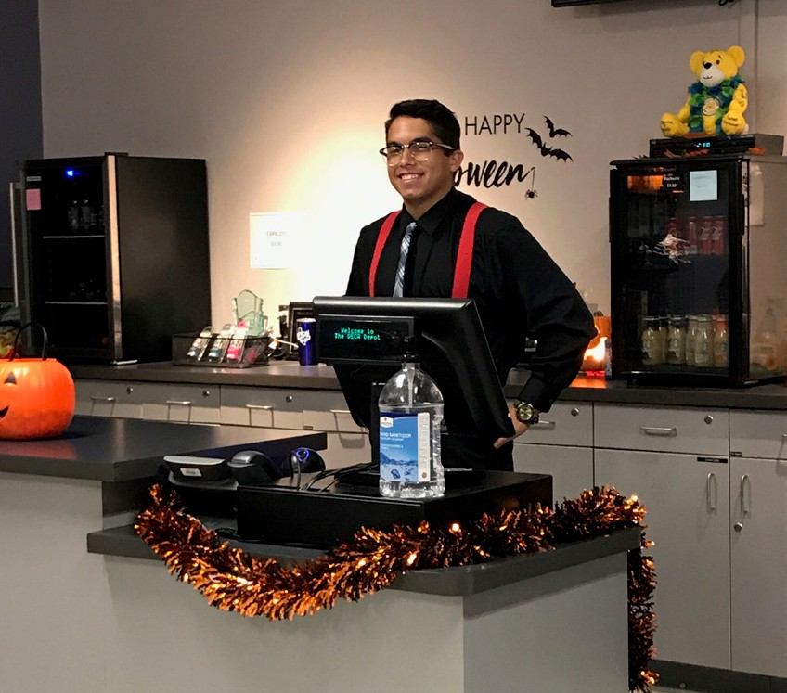
* Meets technology requirement. Location: BCTAL-Birdville Center of Technology and Advanced Learning, HS-high school campus. Un- less otherwise stated, courses are offered at all high school campuses based on student enrollment.



Finance |  | Credits | Grade
HS | Principles of Business, Marketing and Finance | 1 | 9-10
HS | Accounting 1 | 1 | 10-12
HS | Accounting 2 (Mathematics Credit) | 1 | 11-12
BCTAL | Accounting 1/Accounting 2 (Dual Credit) | 2 | 11-12
HS | Financial Mathematics (Mathematics Credit) | 1 | 10-12
HS | Statistics and Business Decision Making (Mathematics Credit) | 1 | 10-12


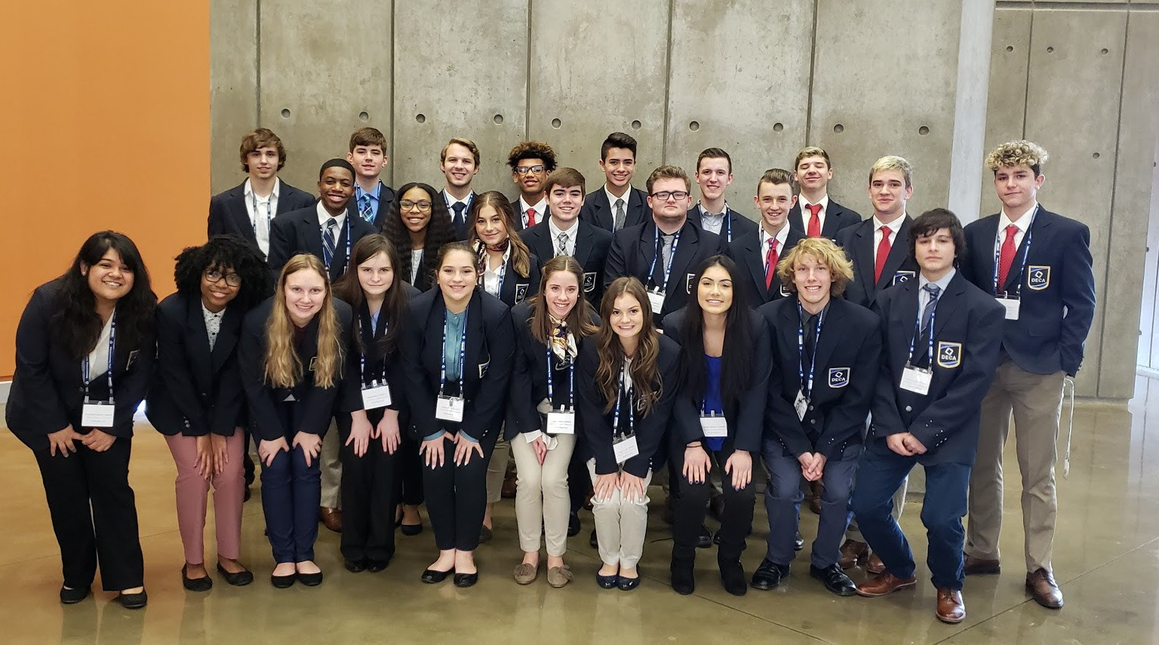
Marketing Credits Grade

HS | Principles of Business, Marketing and Finance | 1 | 9-10
HS | Advertising | 1/2 | 9-12
HS | Social Media | 1/2 | 9-12
HS | Practicum in Marketing | 3 | 11-12
HS | Practicum in Marketing 2 | 3 | 12
HS | Entrepreneurship | 1 | 11-12
HS | Fashion Marketing | 1/2 | 9-12
HS | Sports and Entertainment Marketing | 1/2 | 9-12

Location: BCTAL-Birdville Center of Technology and Advanced Learning, HS-high school campus. Unless otherwise stated, courses are offered at all high school campuses based on student enrollment.
* Meets technology requirement. Location: BCTAL-Birdville Center of Technology and Advanced Learning, HS-high school campus. Unless otherwise stated, courses are offered at all high school campuses based on student enrollment.


Through a partnership with Cisco Systems, BISD offers Cisco Network Academy. Networking and hardware solutions are taught to prepare students to achieve the Cisco certifications. Aircraft maintenance at TCC is a dual credit program available to students interested in becoming licensed airframe and powerplant mechanics.
Information Technology Credits Grade

HS | Principles of Information Technology* | 1 | 9-12
HS | Digital Media* | 1 | 10-12
HS | Web Technologies* | 1 | 10-12
RHS | Computer Programming | 1 | 10-12
BCTAL | Computer Programming/Video Game Design 1* | 2 | 10-12
BCTAL | Game Design 2/3 | 2 | 11-12
BCTAL | CISCO Internetworking Cybersecurity 1* | 2 | 10-12
BCTAL | CISCO Internetworking 2* | 2 | 10-12
BCTAL | Computer Maintenance* | 2 | 11-12
BCTAL | Computer Technician* | 2 | 12

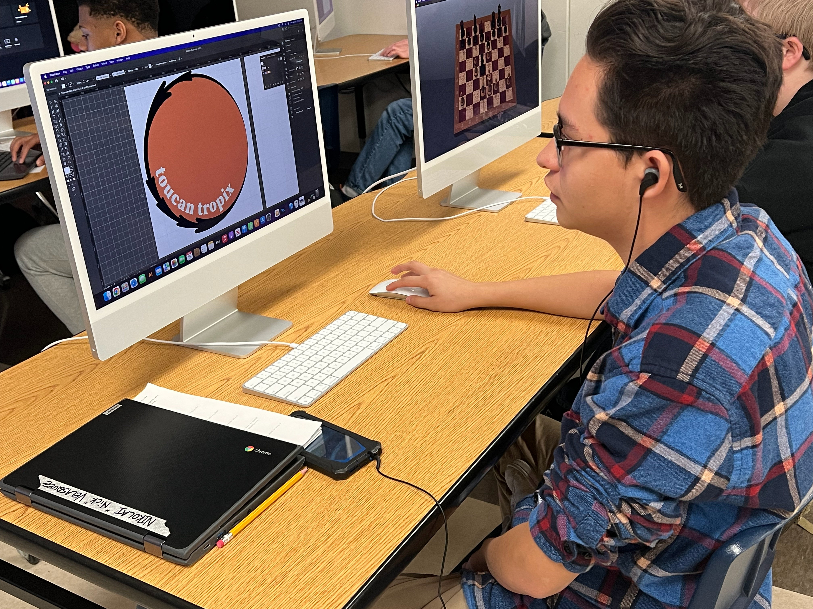
* Meets technology requirement. Location: BCTAL-Birdville Center of Technology and Advanced Learning, HS-high school campus. Un- less otherwise stated, courses are offered at all high school campuses based on student enrollment.
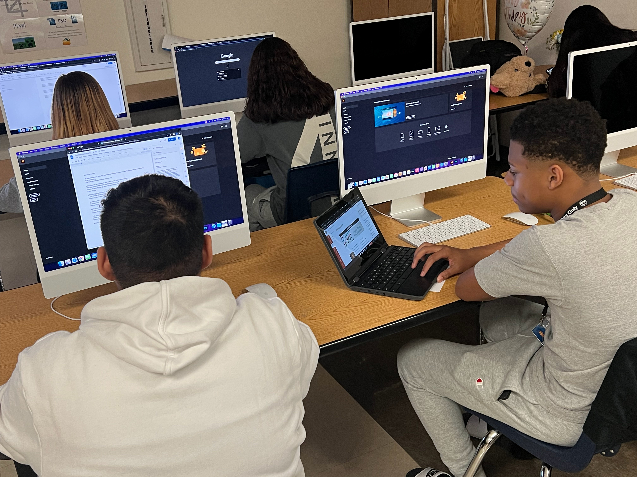
The Cisco® CCNA® Discovery curriculum is primarily designed for Cisco Networking Academy® students who are seeking entry-level information and communication technology (ICT) skills. CCNA Discovery provides general networking theory, practical experience, and opportunities for career exploration and soft-skills development.
CCNA Discovery is designed for students with basic PC skills and foundational math and problem solving skills. Students are not expected to have knowledge of binary math and algorithms. The curriculum provides detailed explanations and tools such as a binary calculator.
Networking Academies are built on Cisco e-learning models enhancing the benefits of personal instruction provided by teachers in traditional classroom settings while taking advantage of media rich technologies. The Cisco Global Learning Network (GLN), uses a number of techniques to help deploy network-enhanced learning solutions.

Education and Training
Credits
Grade

HS | Principles of Education and Training | 1 | 9-12
HS | Human Growth and Development | 1 | 10-12
HS | Instructional Practice in Education and Training | 2 | 11-12
HS | Practicum in Education and Training | 2 | 12
HS | Extended Practicum in Education and Training | 3 | 12

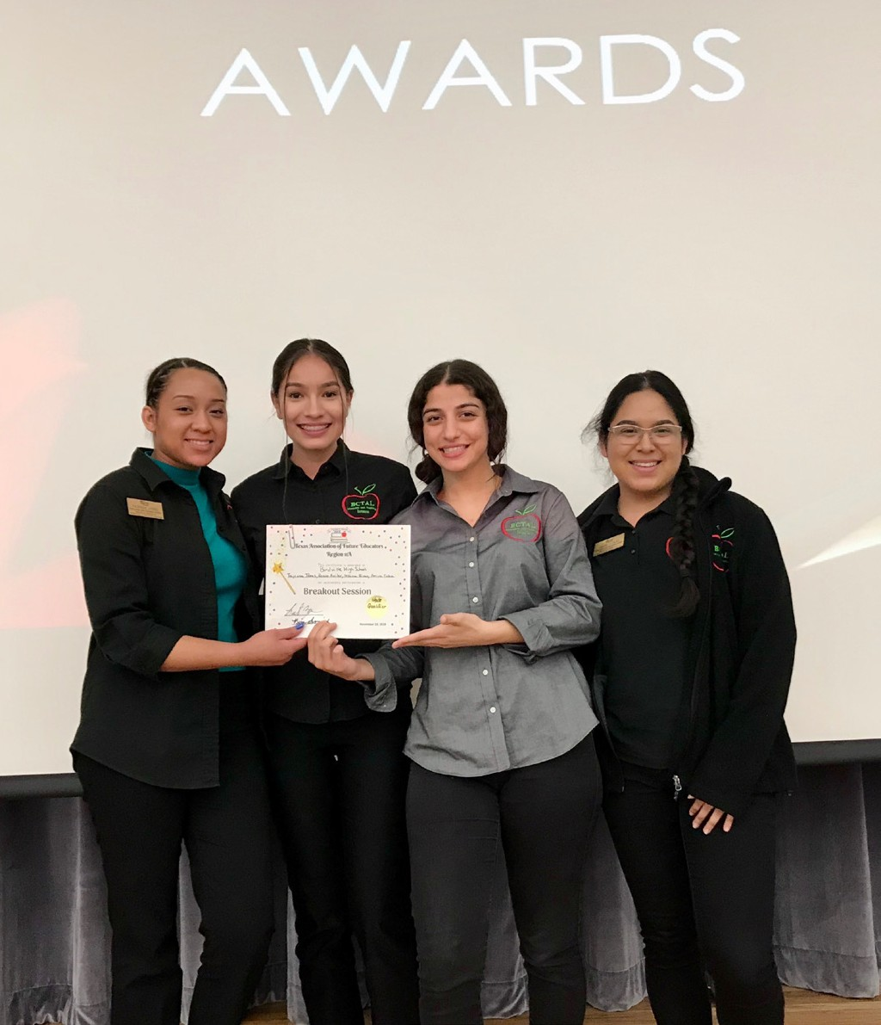
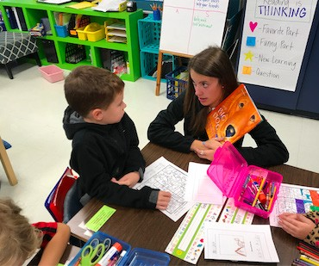
* Meets technology requirement. Location: BCTAL-Birdville Center of Technology and Advanced Learning, HS-high school campus. Un- less otherwise stated, courses are offered at all high school campuses based on student enrollment.


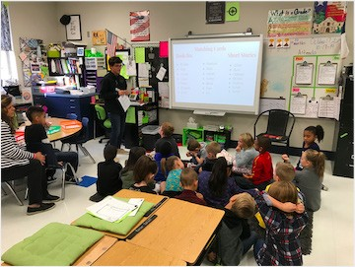
Education and Training includes the understanding of developmental stages of children and preparation for success on the road to becoming a teacher. Stu- dents have the opportunity to observe elementary and middle schools students in classrooms and later assist teach-
ers with class lessons. These courses provide an opportunity for
real-world experience prior to college.


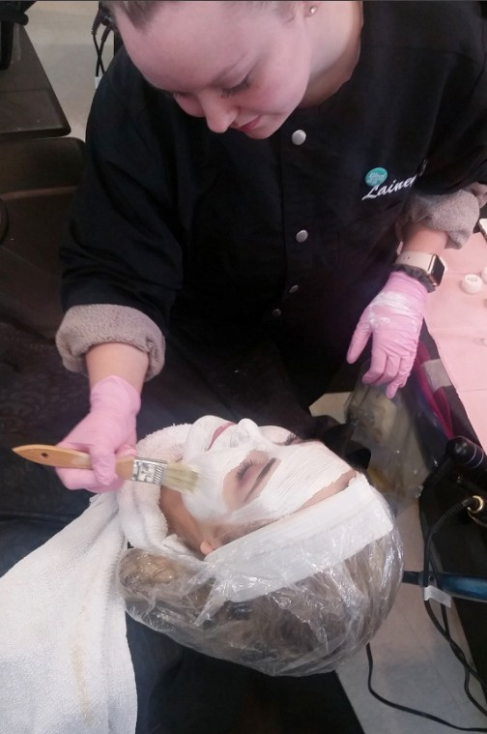
Human Services Credits Grade

HS | Principles of Human Services | 1 | 9-10
BCTAL | Cosmetology 1 | 3 | 11
BCTAL | Cosmetology 2 | 3 | 12
HS | Child Development | 1 | 10-12
HS | Lifetime Nutrition and Wellness (Meets Health Grad Req.) | 1/2 | 9-12
HS | Interpersonal Skills | 1/2 | 9-12
HS | Dollars and Sense | 1/2 | 10-12
HS | Counseling and Mental Health | 1 | 10-12


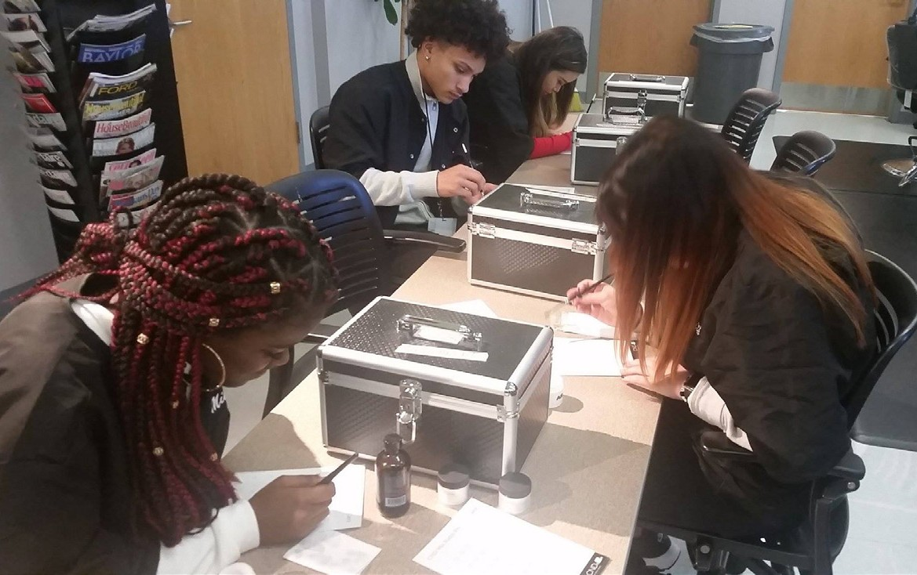

The Cosmetology program provides students with all of the necessary training, hours and experience to take the state examination to become licensed cosmetologists.

Public Services
Career opportunities in the Criminal Justice field are extensive and projected as a high growth area. Students may choose the introductory course to explore career options and/or continue into the more in-depth courses. Students have the option to explore and prepare for careers ranging from emergency operators to a Supreme Court Justice.

Law, Public Safety, Corrections and Security Credits Grade
HS | Prin. of Law, Public Safety, Corrections & Security | 1 | 9-12
BCTAL | Court Systems and Practices | 1 | 10-12
BCTAL | Law Enforcement 1 | 1 | 10-12
BCTAL | Criminal Investigations | 1 | 10-12
BCTAL | Law Enforcement 2 | 1 | 10-12
BCTAL | LPSCS Practicum (911 Dispatch) | 2 | 11-12
BCTAL | Forensic Science (Recommended for Grade 12) | 1 | 12
BCTAL | Firefighter 1 | 2 | 11
BCTAL | Firefighter 2 | 3 | 12

Location: BCTAL-Birdville Center of Technology and Advanced Learning, HS - high school campus. Unless otherwise stated, courses are offered at all high school campuses based on student enrollment.

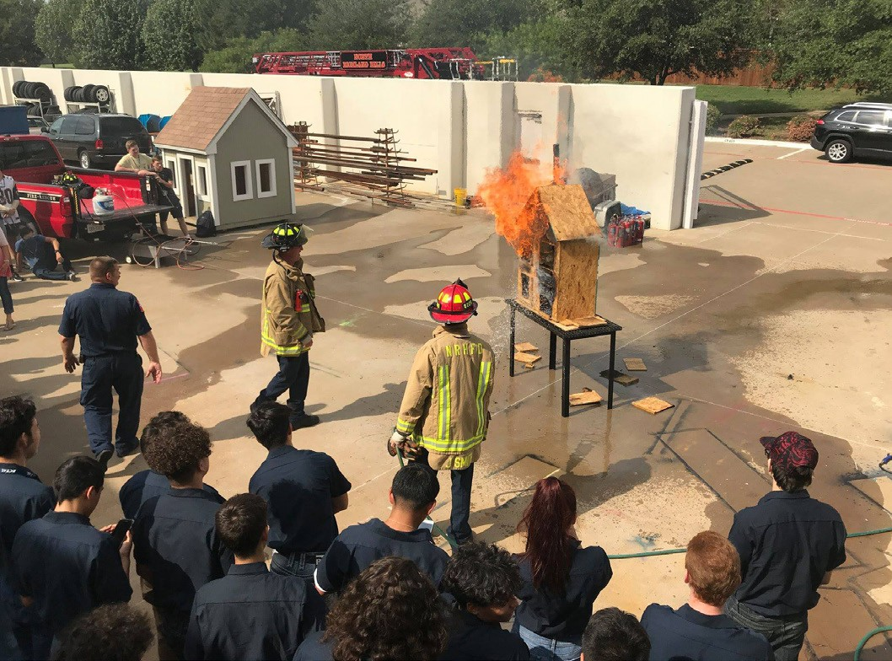
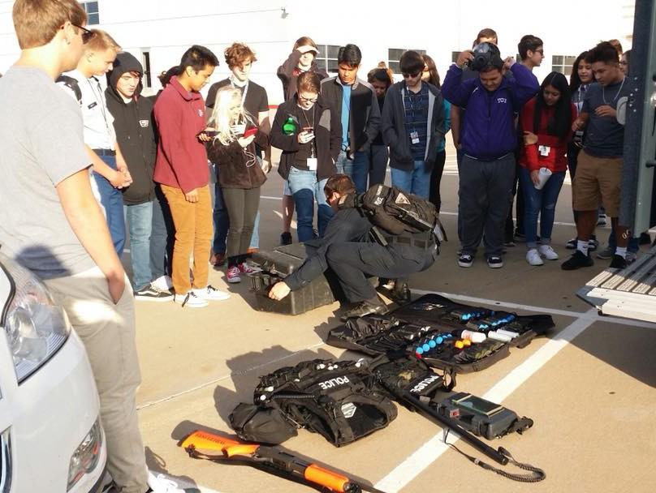

Government and Public Administration Credits Grade
HS JROTC 1, 2, 3, 4 1 9-12
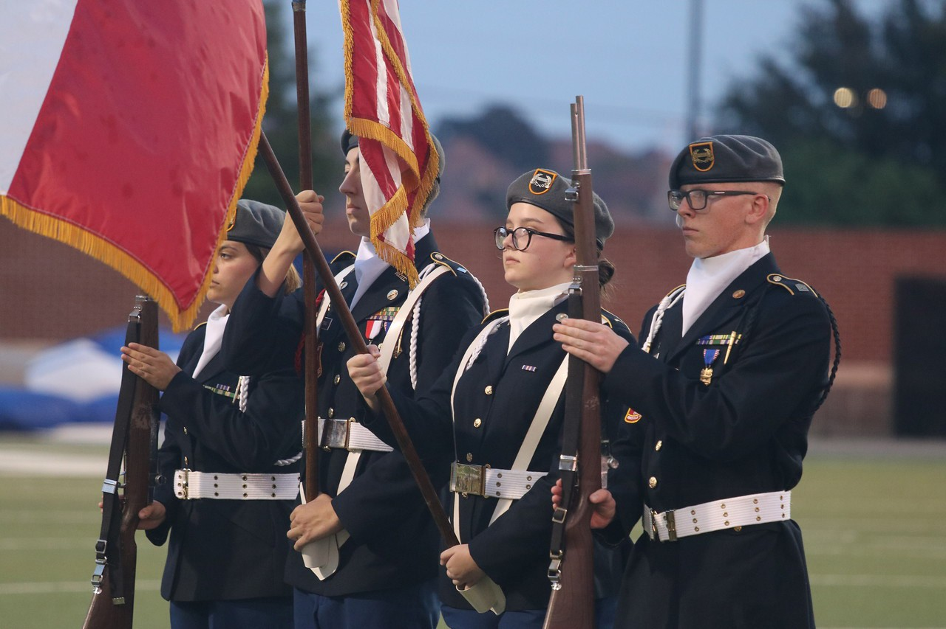
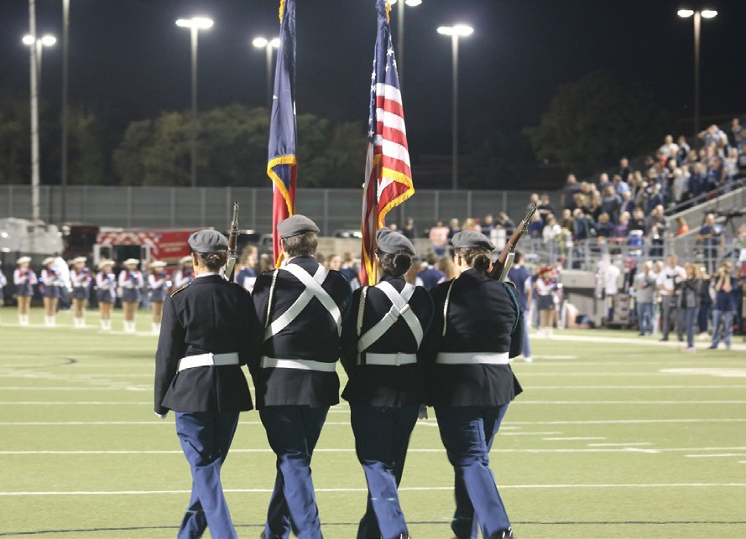


Public Services
Through a partnership with Medical City North Hills Hospital, BISD offers students interested in careers in Health Science opportunities to experience the daily procedures of a hospital in Clinical Rotations. Students gain insight into real world situations by rotating through hospital departments such as: physical therapy, medical and surgical nursing, pediatrics, laboratory, radiology, respiratory therapy and surgery. Students spend 6-8 hours per week in the hospital shadowing staff allowing them to visualize available careers, education and skills necessary to meet their future goals. In their second year students provide hands on care to patients while earning their Patient Care Tech- nician Certification as members of the Future Generations Project. Students earning Phlebotomy Certifications will gain hands on experience in the hospital lab. In addition to the opportunities at Medical City North Hills, students in Pharmacology rotate through local Pharmacies and EMT students complete ride-along experiences with local ambulance crews. Our Sports Medicine students learn side by side with our district trainers at our high schools. A wide range of health science educational opportunities exist for students whether their goals are in hands on medi- cal care or medical administration. Students will be able to enter directly into industry or have a head start on their post-secondary career by earning certifications in our advanced programs.
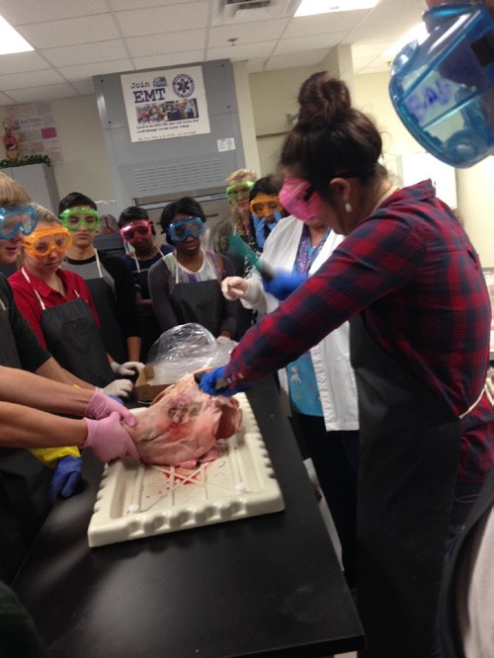
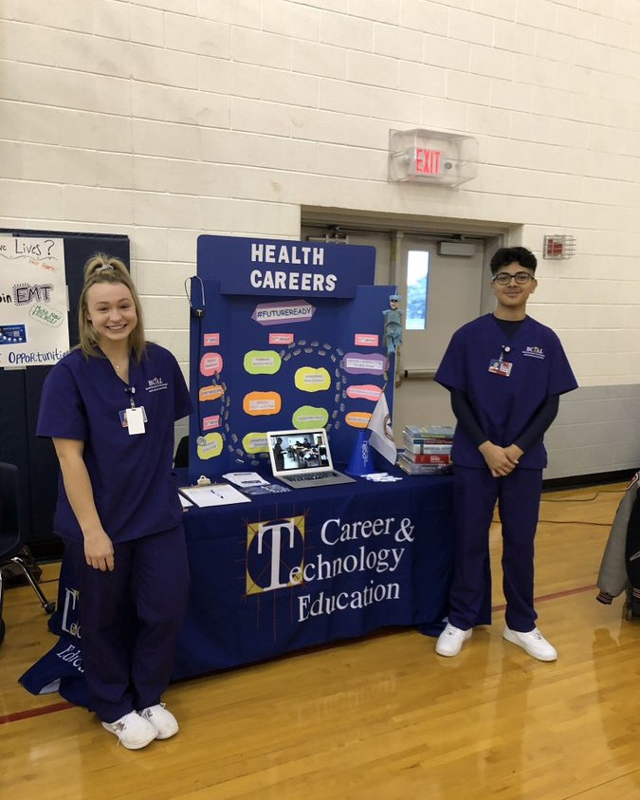
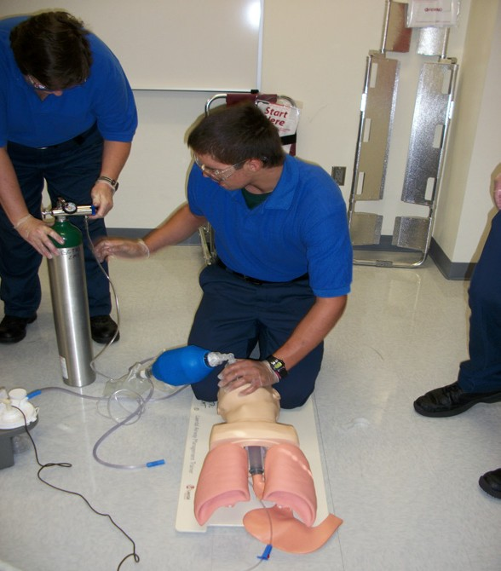
Health Science Credits Grade

HS/BCTAL | Principles of Health Science (Meets Health Grad. Req.) | 1 | 9-11
HS | Medical Terminology | 1 | 9-12
BCTAL | Clinical Rotation 1 (Meets Health Grad. Req.) | 2 | 11-12
BCTAL | Clinical Rotation 2 (Meets Health Grad. Req.) | 2 | 12
BCTAL | Medical Administrative Assistant | 1 | 11-12
BCTAL | Electrocardiogram and Phlebotomy Technician Practicum | 2 | 12
BCTAL | Pharmacology | 2 | 11-12
BCTAL | Pharmacology Clinical | 3 | 11-12
BCTAL | Emergency Medical Technician (EMT) (CE Credit TCC)* | 2 | 12
HS/BCTAL | Anatomy and Physiology/Pre-AP (Science Credit) | 1 | 10-12
BCTAL | Medical Microbiology (Science Credit) | 1 | 11-12
BCTAL | Pathophysiology (Science Credit) | 1 | 11-12
HS | Sports Medicine 1 (Prin. of Health Science/Meets Health Grad. Req.) | 1 | 9-12
HS | Sports Medicine 2 (Health Science/Meets Health Grad. Req.) | 1 | 10-12
HS | Sports Medicine 3 (Practicum in Health Science) | 2 | 11-12
HS | Sports Medicine 4 (Practicum in Health Science, 2nd Time Taken) | 2 | 11-12

*CE- Continuing Education. Location: BCTAL-Birdville Center of Technology and Advanced Learning, HS-high school campus. Unless otherwise stated, courses are offered at all high school campuses based on student enrollment.






STEM (Science, Technology, Engineering and Mathematics)
BISD students have the opportunity to experience various technological applications in pre-engineering courses
through Project Lead The Way programs. Additionally, schools offer Robotics programs that allow students to master advanced academic skills related to robotics design and operation including the rewards of state and national competition.

Science, Engineering and Technology | Credits | Grade
BCTAL Principles of Technology (Physics Credit) | 1 | 10-12
HS Introduction to Engineering Design (PLTW)* | 1 | 9-12
HS Civil Engineering and Architecture (PLTW) | 1 | 10-12
HHS/BCTAL Engineering Mathematics (Mathematics Credit) | 1 | 11-12
BCTAL Engineering Science (PLTW)* (Science Credit) | 1 | 10-12
BCTAL Digital Electronics (PLTW)* (Mathematics Credit) | 1 | 10-12
BCTAL Drone Aerospace Systems (PLTW S2)* | 2 | 10-12
BCTAL Engineering Design and Development (PLTW) | 1 | 11-12
BCTAL Robotics 2* (Mathematics Credit) | 2 | 10-12
BCTAL Robotics 3* (Mathematics Credit-Eng. Des. & Prob. Solv.) | 2 | 11-12
BCTAL CIM Robotics 1 (PLTW S1)* | 2 | 10-12
BCTAL Rocket Engineering 1 (Science Credit-Scientific R&D) | 2 | 10-12
BCTAL Rocket Engineering 2 (Science Credit-Eng. Des. & Prob. Solv.) | 2 | 11-12
HS AP Computer Science Principles (PLTW)* | 1 | 9-12
HS Computer Science AP (Mathematics Credit & LOTE)* | 2 | 10-12

Location: BCTAL-Birdville Center of Technology and Advanced Learning, HS - high school campus. Unless otherwise stated, courses are offered at all high school campuses based on student enrollment.


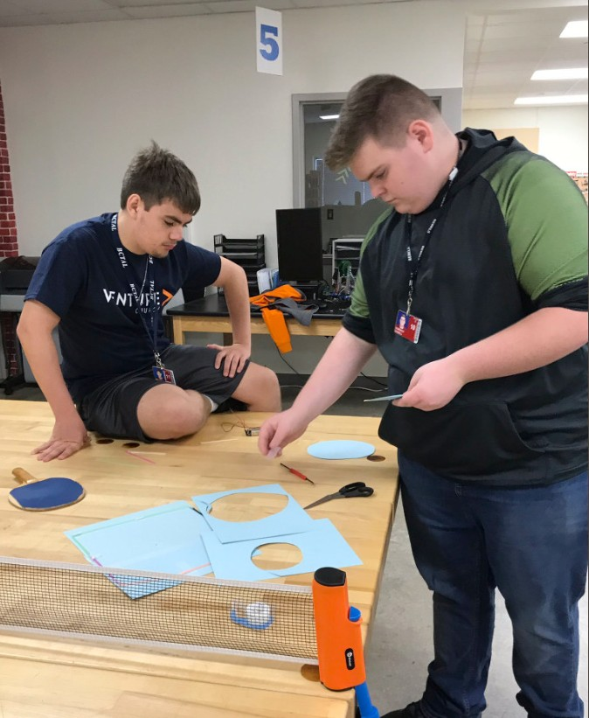

* Meets technology requirement. Loca- tion: BCTAL-Birdville Center of Technology and Advanced Learning, HS-high school campus. Unless otherwise stated, courses are offered at all high school campuses based on student enrollment.
Project Lead the Way (PLTW) will earn weighted credit for students entering 9th grade in 2018-2019 and beyond.

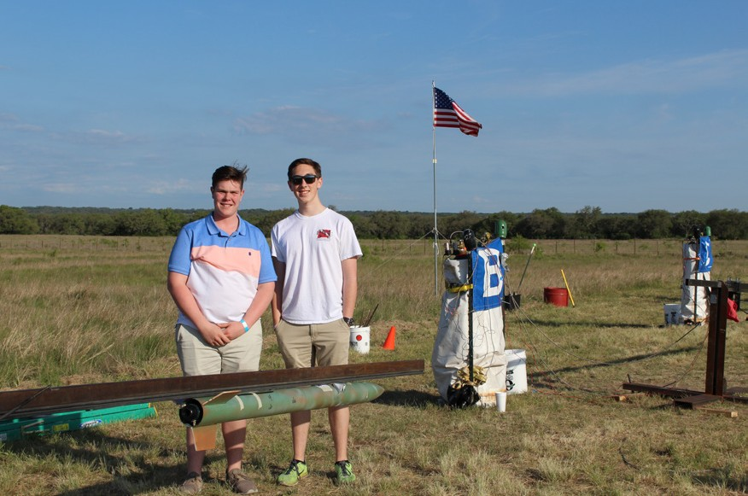
Project Lead The Way’s middle school program, Gateway to Technology, is a project based engineer- ing program designed to challenge and engage the natural curiosity and imagination of middle schools students. PLTW alumni are studying engineering and technology in greater numbers than the na- tional average, with a higher retention rate in co lege engineering, science and related programs than non-PLTW students. PLTW seeks to ignite the spark of ingenuity, creativity and imagination within all students.

By offering a cohesive pre-engineering curriculum, BISD is preparing students for a successful tran- sition to the challenging PLTW high school coursework. At the middle school level, the program is divided into five independent, nine-week units.

Middle School

Middle school is a time for students to begin thinking about the actual coursework they will need to reach their college and career goals. Classes focused on career exploration and interest help students make informed choices going into high school. In addition to encouraging a challenging program, BISD also awards high school credit for completion of certain middle school courses. Career pathways offer ideas for possible programs of study students should consider based on their measured career interests.

Middle School Programs High School Credits

MS | College & Career Readiness (Semester Course) | 1
MS | Investigating Careers
MS | Principles of Manufacturing* | 1
MS | Principles of Information Technology (Semester Course)* | 1
MS | Principles of Audio Video Technology & Communications* | 1
MS | Gateway to Technology - 1 Design, Modeling and Automation* | 1/2
MS | Gateway to Technology - 2 Applied Science and Technology* | 1/2
MS | Gateway to Technology - 3 Energy, Environment and Flight* | 1/2
MS | Gateway to Technology - 4 Architecture and Bio Medical* | 1/2
MS | Principles of Hospitality and Tourism | 1
MS | Touch System Data Entry | 1/2

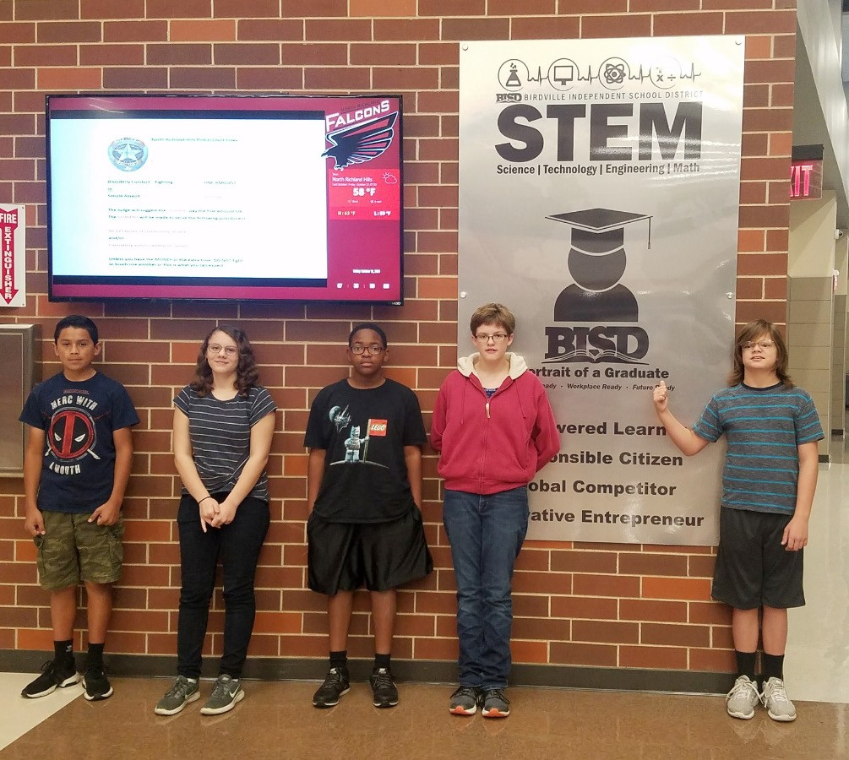
*Meets technology requirement. Course availability varies by campus.



Middle School students have the opportunity to participate in the Vital Link cooperative program, which is of- fered along with the Northeast Tarrant County Chamber of Commerce, for 4 days each summer to 8th grade students who are interested in encountering experi- ences in the real world to help motivate them to further their acdemic endeavors.

The chief goal is for every student to choose a program of study and adjust it as he or she develops as a result of the career exploration experience.

Student Organizations
Students participating in Career and Technology Education classes have the opportunity to become involved in many different student leadership organizations and compete in skills areas in state and national levels. Career and Technology Student Organizations (CTSOs) are co-curricular and bring relevance to the classroom through rigorous industry related competitions, preparing students to be college and career ready. In addition to competition, students gain valuable experience by participating in a variety of group activities and community service projects while developing leadership skills and building self-confidence.

DECA (Professional Association of Business and Marketing Students) prepares emerging leaders and entrepreneurs in marketing, finance, hospitality and management in high schools and
colleges around the globe. 

Health Occupations Students of America (HOSA) is a student organization whose mission is to promote career opportunities in health care
and to enhance the delivery of quality healthcare to all people.

SkillsUSA’s mission is to help its members become world-class workers, leaders and responsible American citizens.


Business Professionals of America is the premier CTSO (Career and Technical Student Organization) for students pursuing careers in business management, information technology, finance,
office administration and other related career fields.

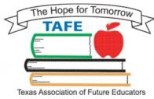
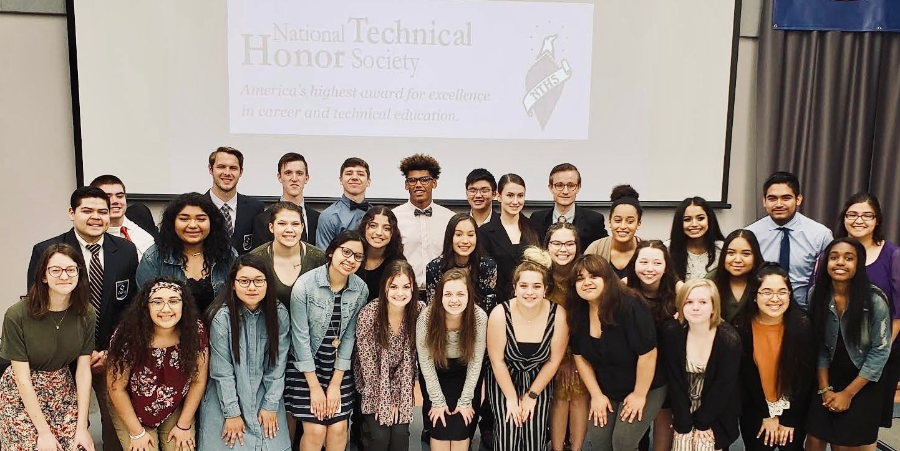

The National Technical Honor Society (NTHS) encourages higher scholastic achievement, cultivates a desire for personal excellence, and helps top students find success in today’s competitive workplace.
a statewide organization that offers students the opportunity to explore the teaching
profession.
Family, Career and Community Leaders of America (FCCLA) is a nonprofit national career and technical student organization for young men and
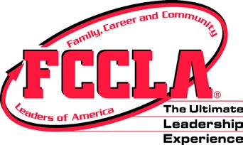
women in Family and Consumer Sciences education in public and private schools through grade 12.

The Technology Student Association (TSA)
fosters personal growth, leadership and opportunities in technology, innovation, design and engineering.
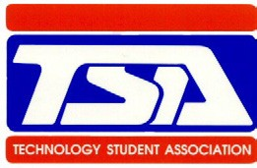
Members apply and integrate science, technology, engineering and mathematics concepts
through co-curricular activities, competitive events and related programs.

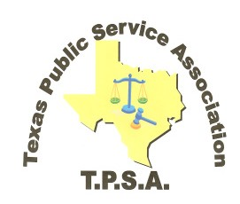
Texas Public Service Association (T.P.S.A.) is and organization which promotes Law Public Safety Corrections and Security students with knowledge, skills, leadership, and student growth
through real world career preparation, experience, training and competition opportunities.

The National FFA Organization envisions a future in which all agricultural education students will discover their passion in life and build on that insight
to chart the course for their education, career and personal future.

Texas Association of Future Educators (TAFE) is

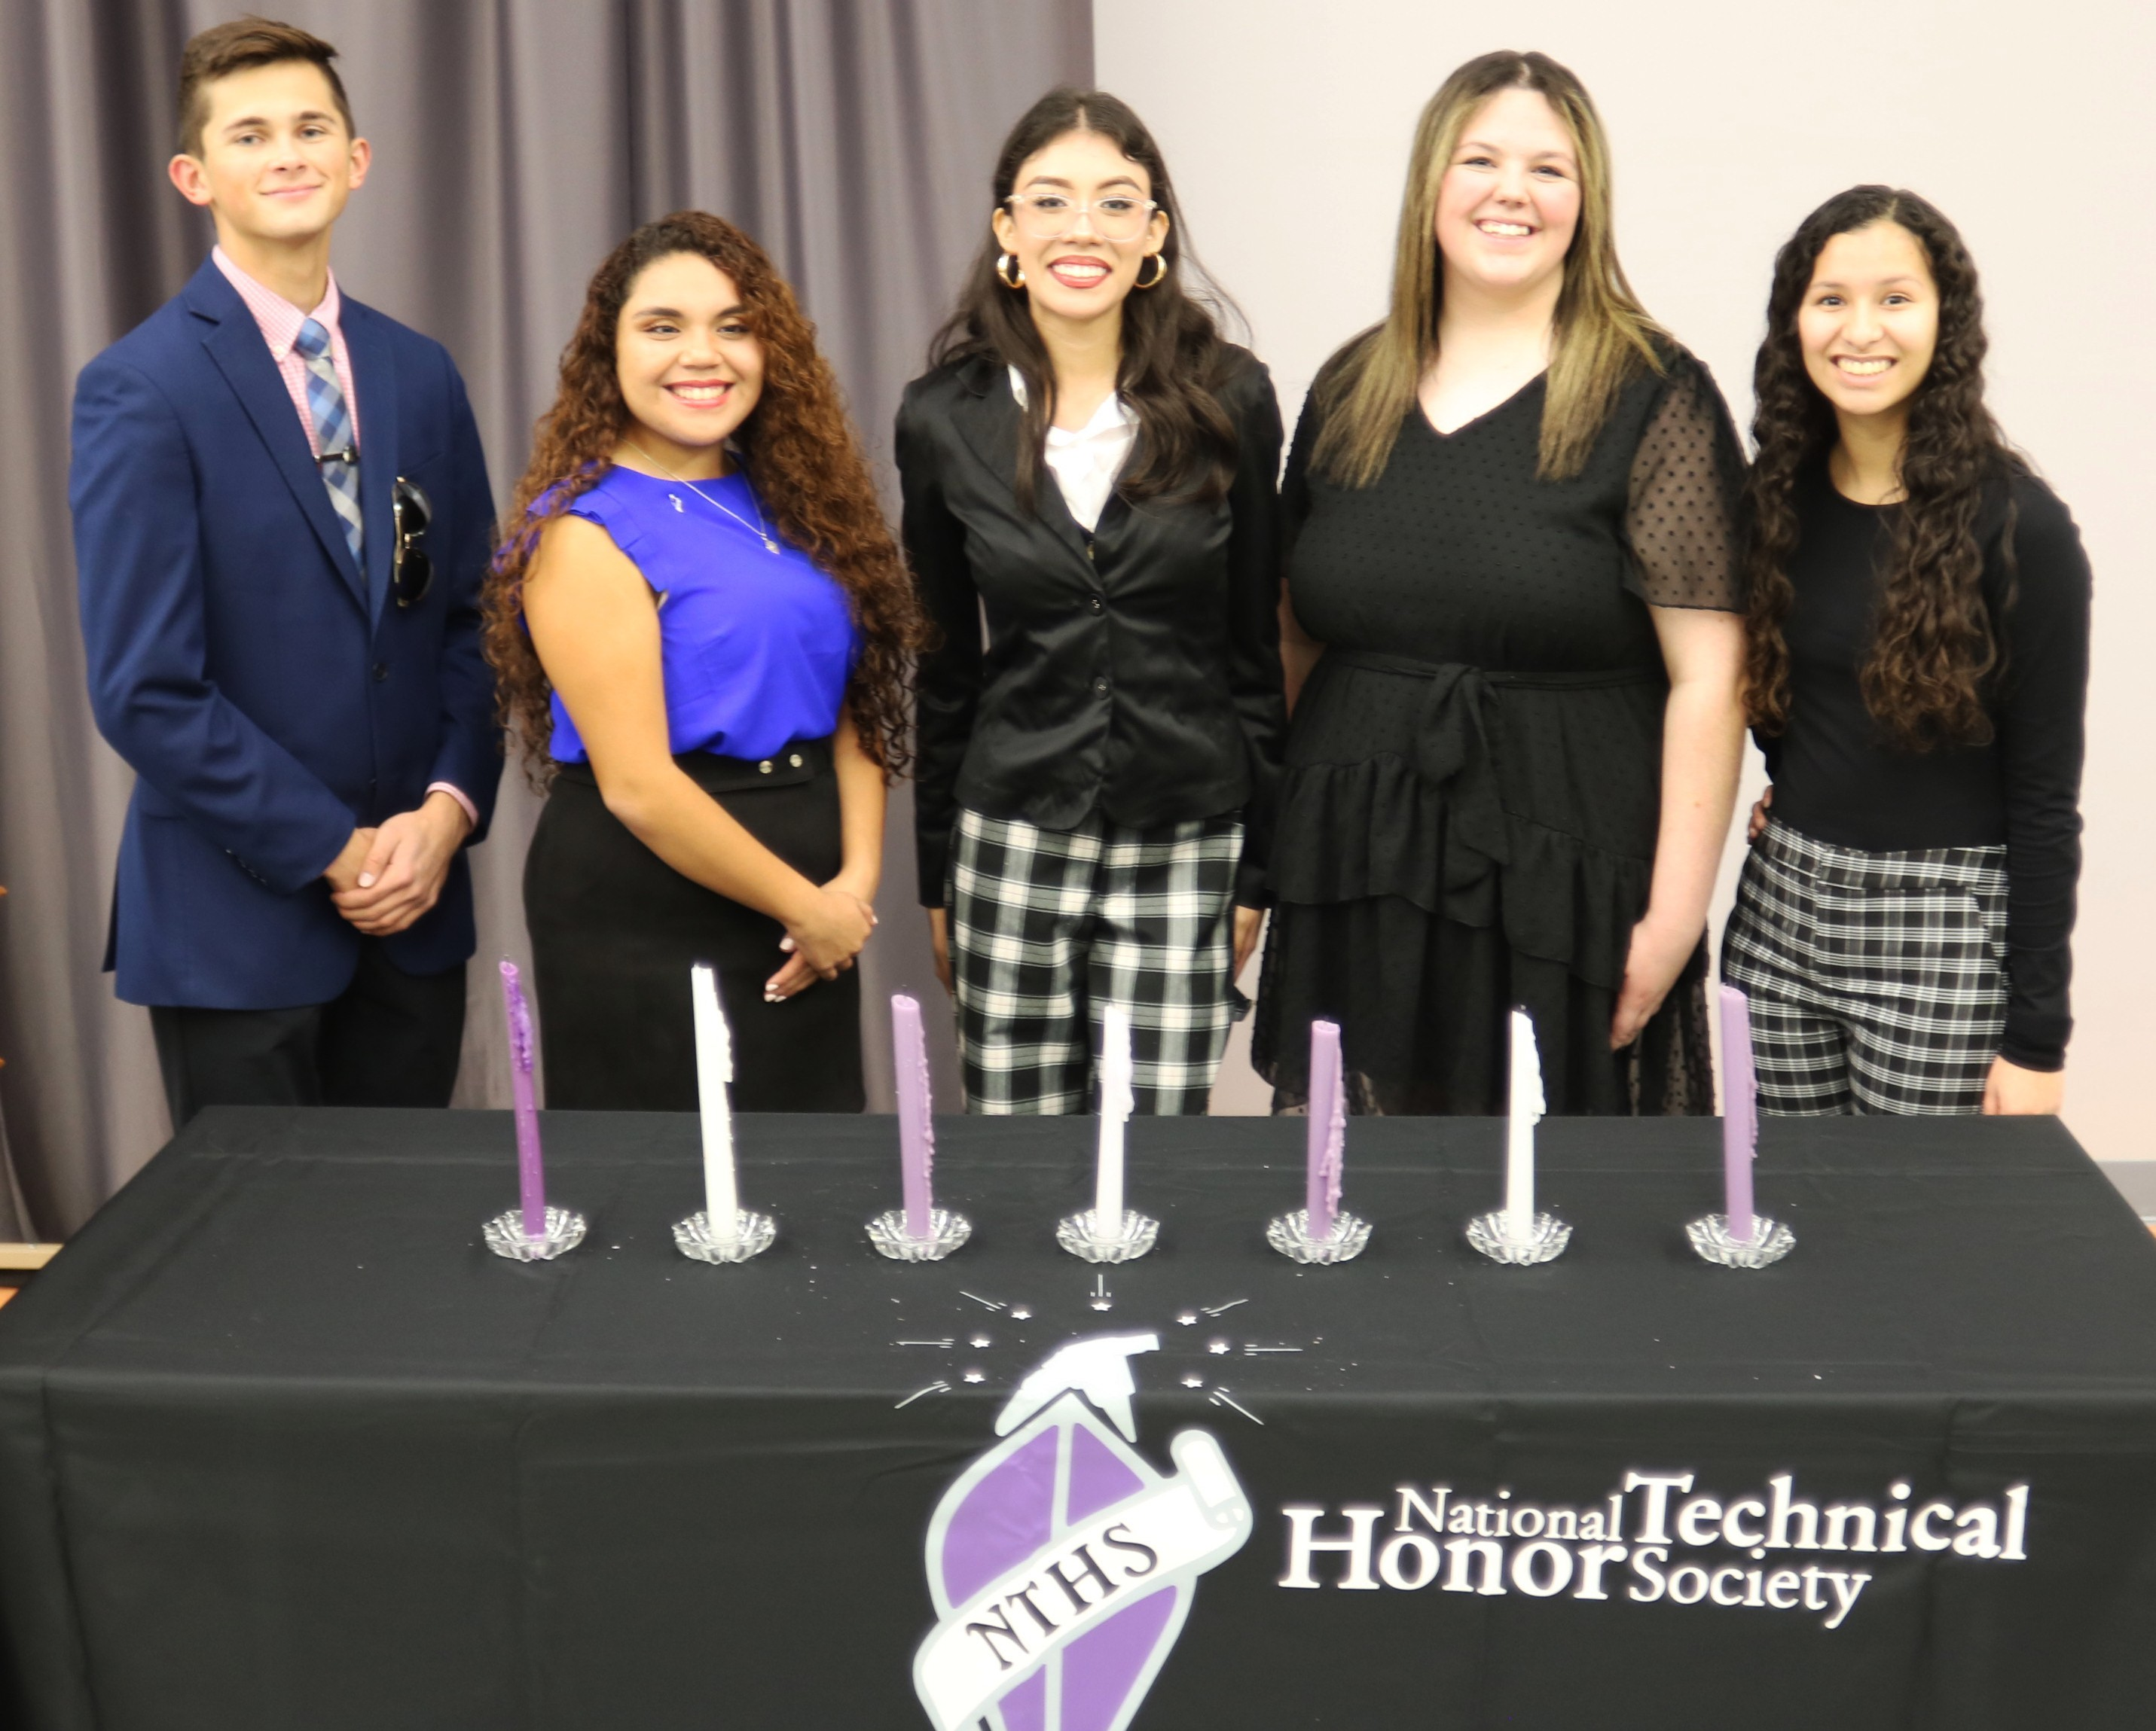



Career and Technology Education Department
7020 Mid Cities Blvd.
North Richland Hills, Texas 76180 (817) 547-3800



BIRDVILLE INDEPENDENT SCHOOL DISTRICT
6125 East Belknap Street Haltom City, Texas 76117
(817-547-5786

